Chapter 9 Outline

Lesson 1: The Nature of Chemical Reactions

-Chemical reaction is a process in which one or more substances are converted into new substances with different physical and chemical properties

-Reactant what enters a chemical reaction

-Product what reactant become after the reaction

Lesson 2: Chemical Equations

* Chemical reactions are represented by sentences known as chemical equations

Calcium + Oxygen => Calcium Oxide

* Word equation most simplest form

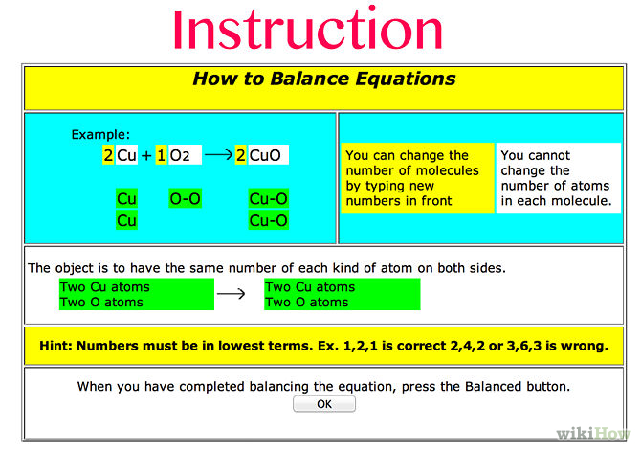

* For mass to remain constant before and after a chemical reaction, the number of atoms of each element must be the same before and after a chemical reaction
* Coefficients whole numbers written before the formulas for reactants and products

Lesson 3: Classifying Chemical Reactions

* The 4 general types of chemical reactions are classified as follows

Direct Combination Reactions

* Two or more reactants come together to form a single product
* A+B=AB
* 2 Na + Cl2=>2NaCl

Decomposition Reactions

* A single compound is broken down into two or more smaller compounds or elements
* AB=>A+B
* CaCO3=>CaO+CO2

Single Replacement reactions (Switcherroo)

* An uncombined element displaces an element that is part of a compound
* A+BX=>Ax+B
* Mg+CuSO4=>MgSO4+Cu

Double Replacement Reactions

* Atoms or ions from 2 different compounds that replace each other
* AX+BY=>AY+BX
* CaCO3+2HCl=>CaCl2+H2CO3

Chapter 10: The Mole

Lesson 1: Chemical Measurements

Atomic Mass and Formula Mass

1. Atomic mass is the mass of an atom in amu
2. Formula mass is the sum of all the atomic masses of all the atoms in a compound

What is a Mole?

1. A hella large number of 602,000,000,000,000,000,000,000,000 or 6.02x10^23
2. Mass in grams of one mole of a substance is numerically equal to its atomic mass or formula mass in amu
3. The number of molecules in a mole of any molecular compound is 6.02x10^23 same as atoms

Avogadro ’s number

1. The quantity of items in a mole

Molecular Mass

1. The mass in grams of 1 mole of a substance is called the molar mass of the substance